***Covid Counts Findings***

**Goal**: To study how fatal Covid-19 is by age and gender and to determine if over time we have been able to treat and reduce death rates by percentage in California, New York, Texas and Virginia

*How fatal is Covid-19 to the young and old?* This question is important to us in determining severity of cases and how to reopen during the pandemic.

*How fatal is Covid-19 to men vs women?* The role sex and gender are playing in the COVID-19 outbreak is essential to building an effective, equitable response to the pandemic.

*Are the death percentages rising or falling as we treat COVID-19?* The data overtime can help us analyze our response to the pandemic.

1. **How fatal is Covid-19 to the young and old?**

Covid-19 has followed the trend it has shown since the beginning, being utterly dangerous to the elderly. The data shows that our nation’s elderly has been hit the hardest with deaths above 160,000. While those under 55 has not been hit nowhere near as hard, with the hardest being hit is the age group of 45 to 54 with a total of 23,912 deaths. Looking at our four states this is proven once again as the greater percent has been individuals 85 and older, except for Texas. Texas saw a more even split between the three elderly age groups. No other group even comes close to the pain and devastation that our elderly has endured.

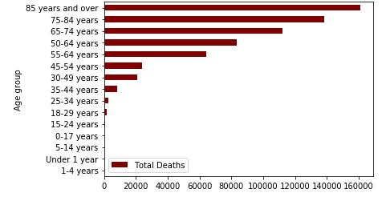

1. **How fatal is Covid-19 by gender?**

We can confidently say from the data that being male is a risk factor. Overall total death percentages between men and women were remarkably like the percentage totals for COVID deaths among men and women. Therefore, overall, there are clear gender differences in COVID deaths. We used 4 subsets of data to drill down into the overall data presented and found some unexpected results. While California and Texas followed the expected path of having a greater percentage of men die from COVID than women, New York and Virginia had nearly equal percentages of deaths between the sexes. It would be interesting to explore the reason for this unexpected result.

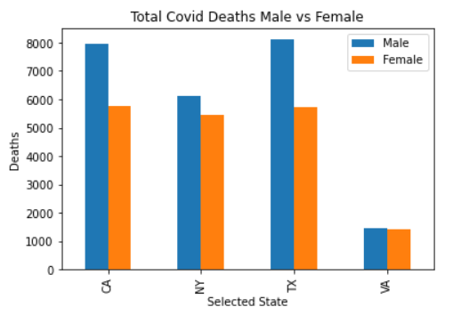

1. **Are the death percentages rising or falling as we treat Covid-19?**

The data shows an increase in the percentages of new cases that end in fatalities between our targeted states with California being the exception. I would like to dig deeper into why California has been successful in lowering their death % but with the current time and data we can only speculate. I would venture a guess it has to do with obesity rates among a wide variety of other variables. We do however see pretty drastic turnarounds in a number of cases. These can be attributed to a number of factors as well but I was able to look into statewide policies and the timelines they implemented them. One key factor I found was in mere days of each states implementation of the universal mask mandates every single state experienced a major drop in cases.

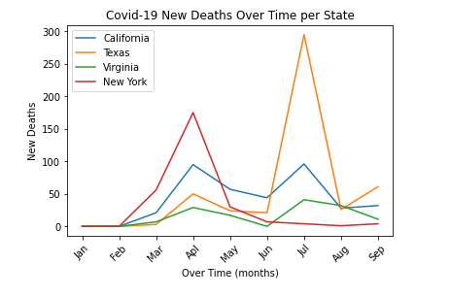

*In the graph we can see a major drop in cases for Texas and California around the start of July. California implemented their universal mask mandate on June 18th and Texas on July 3rd. This data was also sourced from HealthData.gov.